Reflecting light

Some objects are good at reflecting light.
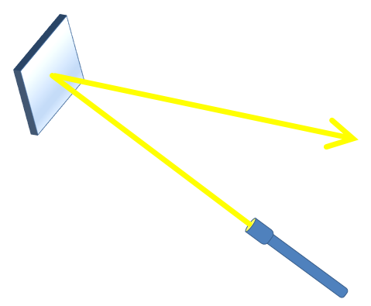

Which of these objects can reflect light?
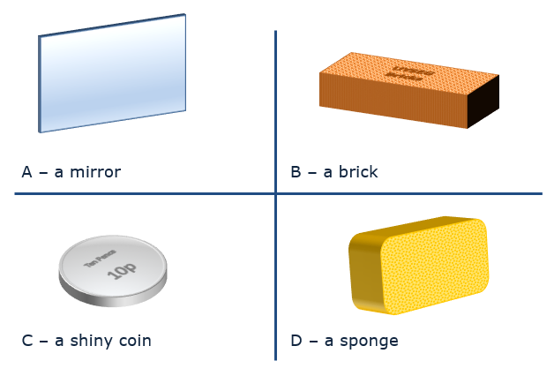

Physics > Big idea PSL: Sound, light and waves > Topic PSL1: Sound and light > Key concept PSL1.2: Characteristics of light
Diagnostic question
Reflecting light

Overview
Learning focus: | Light is reflected from all surfaces, and off a flat mirror it is reflected in a single direction.
Observable learning outcome: | Identify surfaces that reflect light.
Question type: | Simple multiple choice
Key words: | Light, reflect, shiny, rough

P | PRIOR UNDERSTANDING  This diagnostic question probes understanding of ideas that are usually taught at age 5-11, to aid transition from earlier stages of learning.

What does the research say?
When light reflects Anderson and Smith (1986) found that, out of 125 ten and eleven year olds, about 60% described light bouncing off only mirrors and not off other opaque objects. Just 20% thought light did bounce off opaque objects, with only 2% suggesting it is scattered.
This question checks which types of surface students think will reflect light.
Ways to use this question
Students should complete the question individually. This could be a pencil and paper exercise, or you could use an electronic ‘voting system’ or mini white boards and the PowerPoint presentation.
The answers to the question will show you whether students understood the concept sufficiently well to apply it correctly.
If there is a range of answers, you may choose to respond through structured class discussion. Ask one student to explain why they gave the answer they did; ask another student to explain why they agree with them; ask another to explain why they disagree, and so on. This sort of discussion gives students the opportunity to explore their thinking and for you to really understand their learning needs.
Differentiation
You may choose to read the questions to the class, so that everyone can focus on the science. In some situations it may be more appropriate for a teaching assistant to read for one or two students.
Expected answers
All the objects reflect light

How to respond - what next?
Different surfaces reflect light to a greater or a lesser extent than each other. Surfaces that are both smooth and irregular, like those of a coin, reflect light strongly in particular directions and hardly at all in others. This gives some objects a bigger contrast between light and dark which makes them appear shiny. Mirrors are both smooth and flat.
If students have do not understand that all objects reflect light, it can help to demonstrate how light is reflected by coloured paper. In the example below the white paper is coloured by the green light reflected onto it. This can be seen more clearly by comparing to other colours of paper that the light is reflected off.
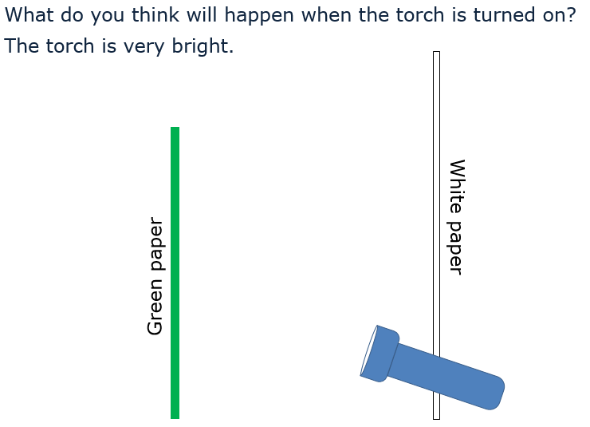
A ray-lamp works well for this demonstration.
Asking students to discuss their ideas of what is happening in pairs or small groups, can encourage social construction of new ideas through dialogue.
Acknowledgments
Developed by Peter Fairhurst (UYSEG).
Images: UYSEG
References
Anderson, C. W. and Smith, E. L. (1986). Childrens' conceptions of light and colour: developing the concept of unseen rays. Annual meeting of the American Educational Research Association. Montreal, Canada.

